February 2, 2022 | CSE: FABL

Fabled Copper Examines Underground Workings at Harris Vein, Sampling 2.96% copper over 1.7 meters at Surface and Announces Listing on the Frankfurt Stock Exchange

Vancouver, British Columbia – Fabled Copper Corp. (“Fabled Copper” or the “Company”) (CSE: FABL; FSE: XZ7) announces the fourth set of results from the 2021 surface field work on it’s Muskwa Copper Project, comprised of the Neil Property (previously referred to as the North Block) and the Toro Property (previously referred to as the South Block) in Northwestern British Columbia. The Company also holds rights to the Bronson Property. See Figure 1 below.

Figure 1 – Location Map

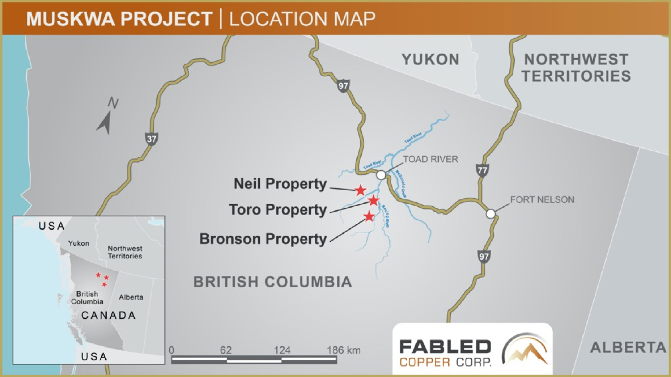

Peter J Hawley, President, CEO reports; “We started the New Year by reporting our findings on the Lady Luck occurrence in the south end of the Neil Property, followed by the Mac occurrence and the 8A occurrence further to the north and now we move further north again to the Harris copper occurrence. See Figure 2 below.

Figure 2- Neil Property, Harris Location
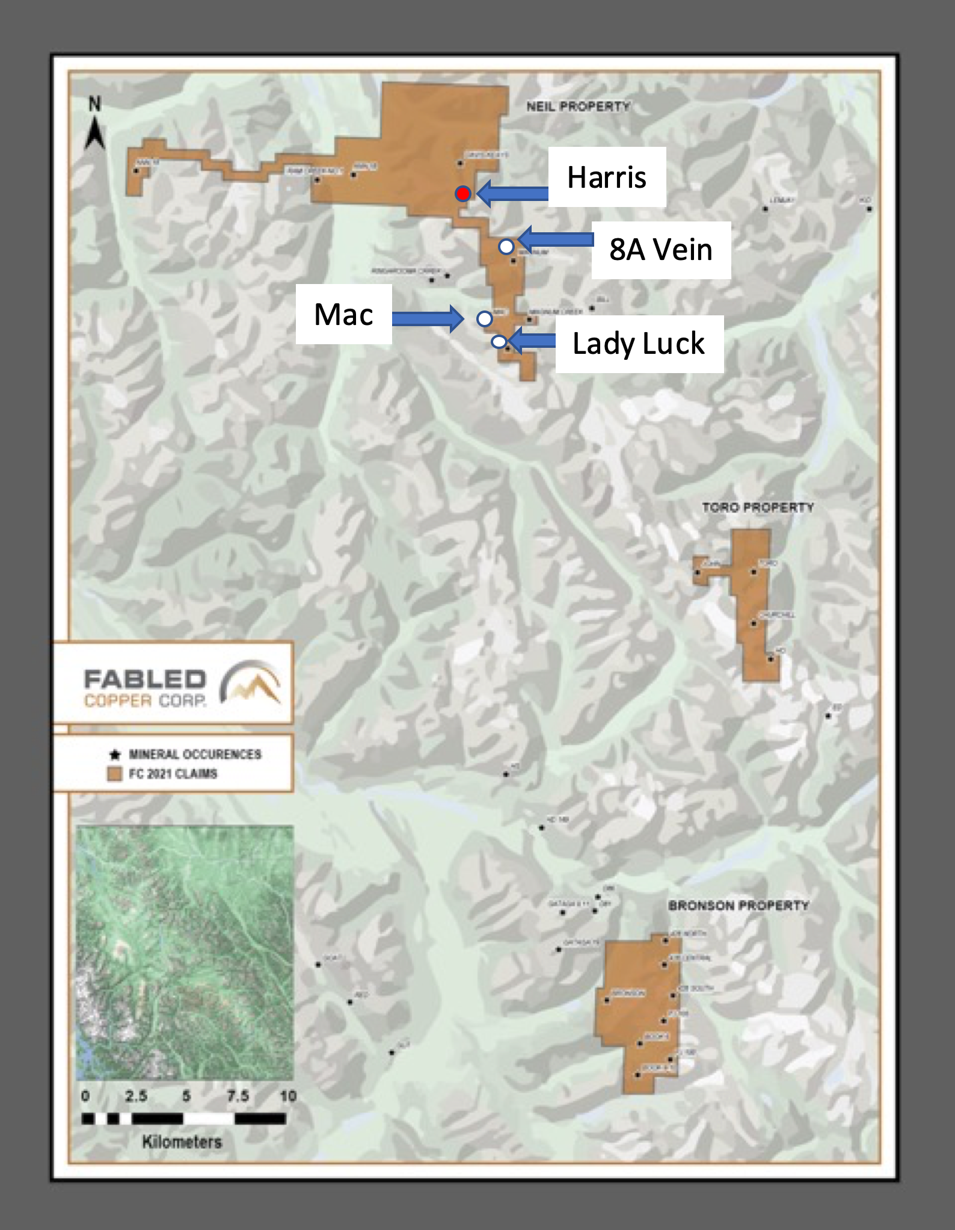
The Host rocks of the Harris copper vein occurrence consist of fine grained gray slates, finely interbedded or layered with black shales. See Photo 1 below.
Photo 1 – Harris Occurrence Host Rocks
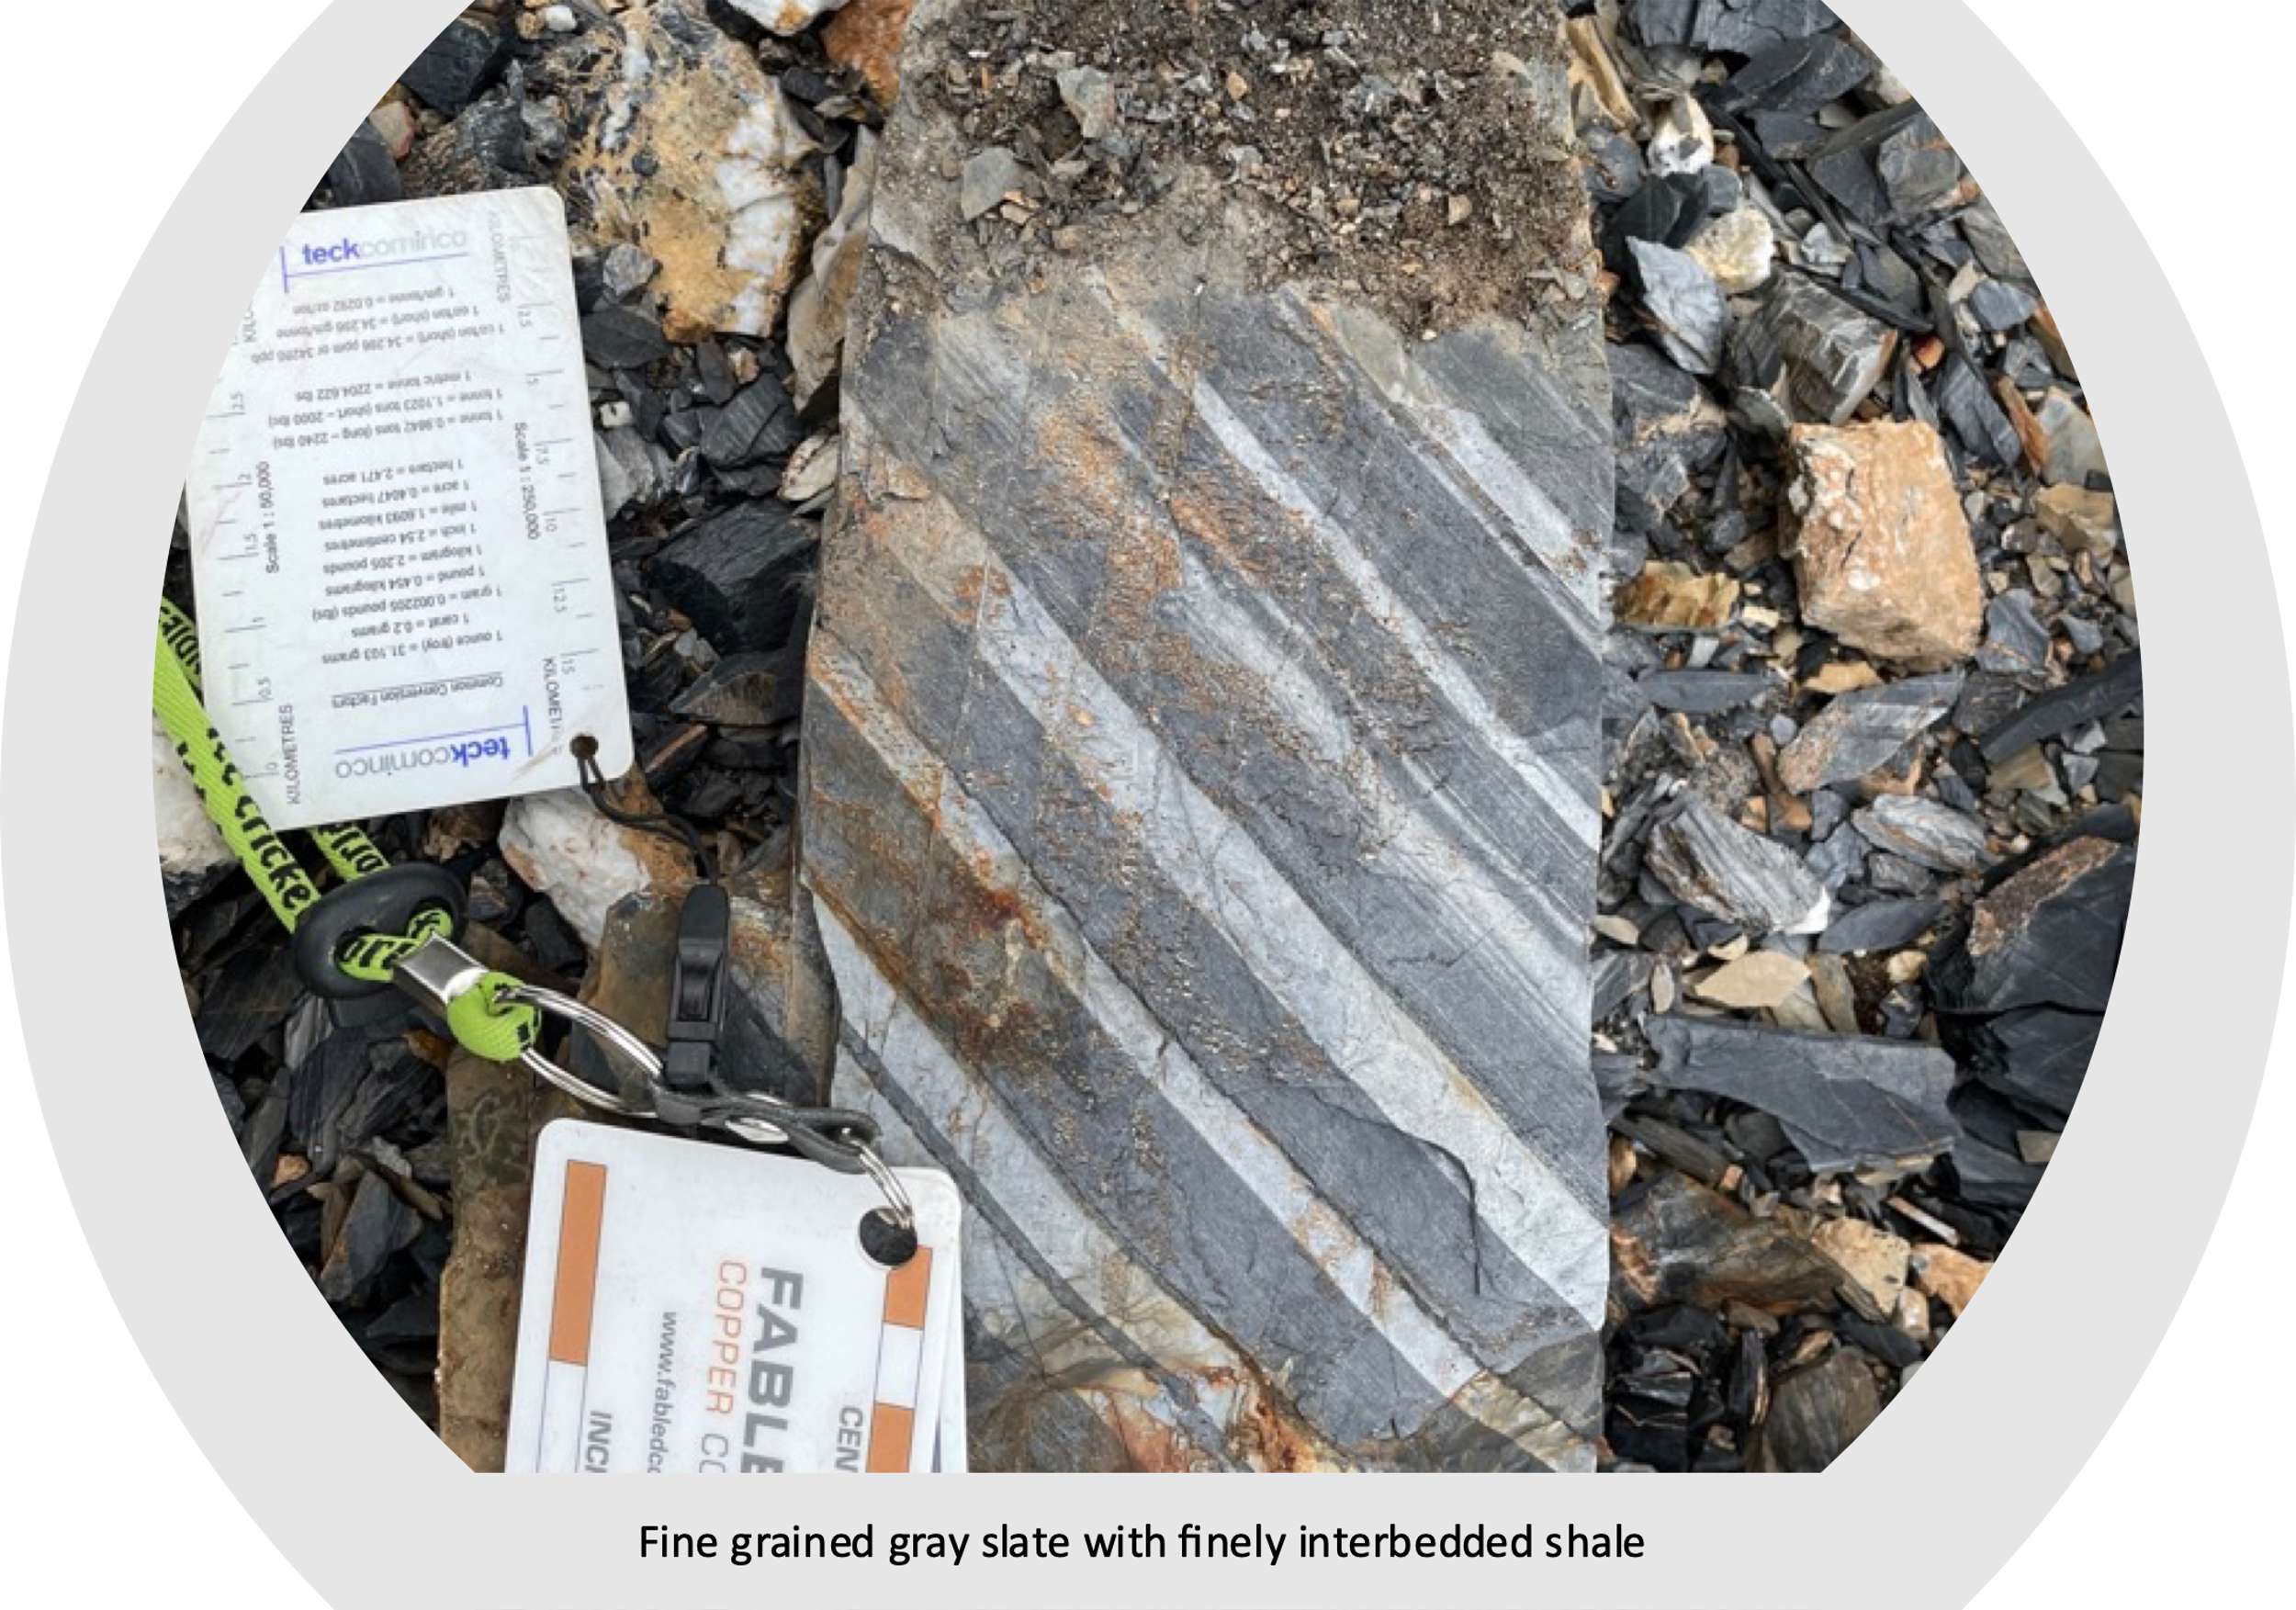
The portal of the Harris vein is located at 1,782 meters vertically and a rubble sample D-723396 taken at adit entrance consisted of quartz, dark rusty brown on the weathered side, and white with sub-netted textured and in part fracture filling with yellow – yellowish gray sulphides of pyrite and chalcopyrite with 5% chalcopyrite, 10% pyrite and pyrite incapsulating the chalcopyrite in places. This sample assayed 2.96% copper. See Table 1 below.
30 meters above the adit the internal Harris vein is intersected and the drift follows the vein for another 118 meters. The drift ranges from 2.0 - 3.5 meters in width and 2 - 3 meters in height. See Photo 2.
Photo 2 – Harris Vein Underground Portal – 1,782 meters vertical
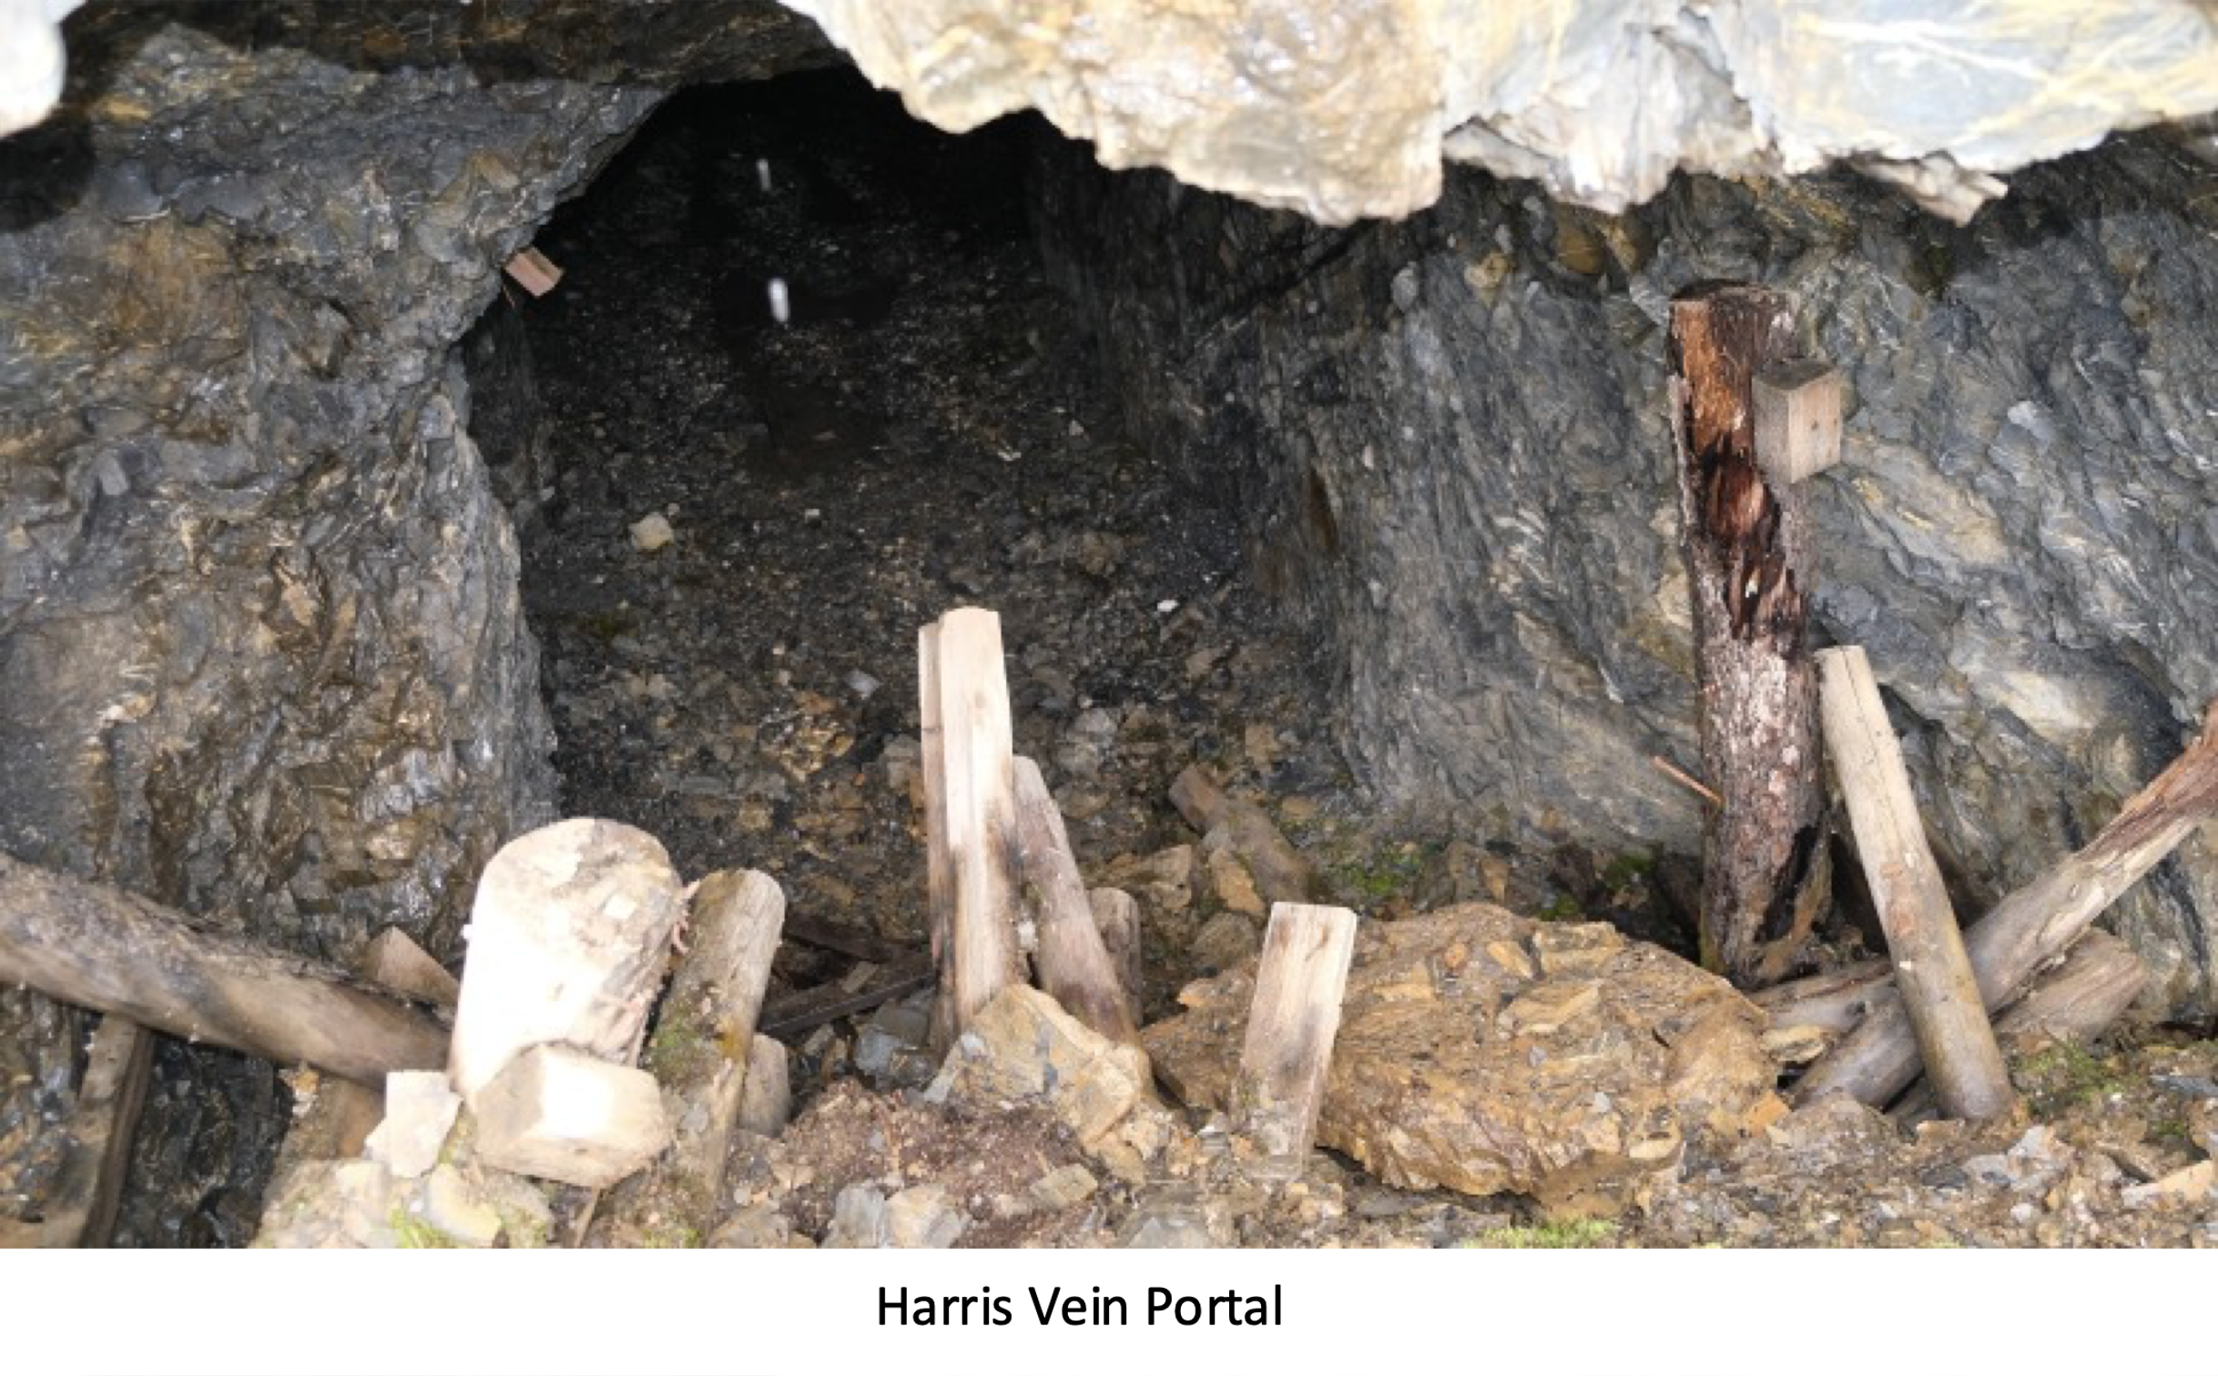
The Harris vein proper, is composed of bull white quartz and carbonate with blobs, blebs and stringers of chalcopyrite which can be massive at times. It appears the vein in truncated by the nose of a synclinal fold. See Photo 3 below.

Photo 3 – Harris Vein Underground Veining – 1,782 meters vertical

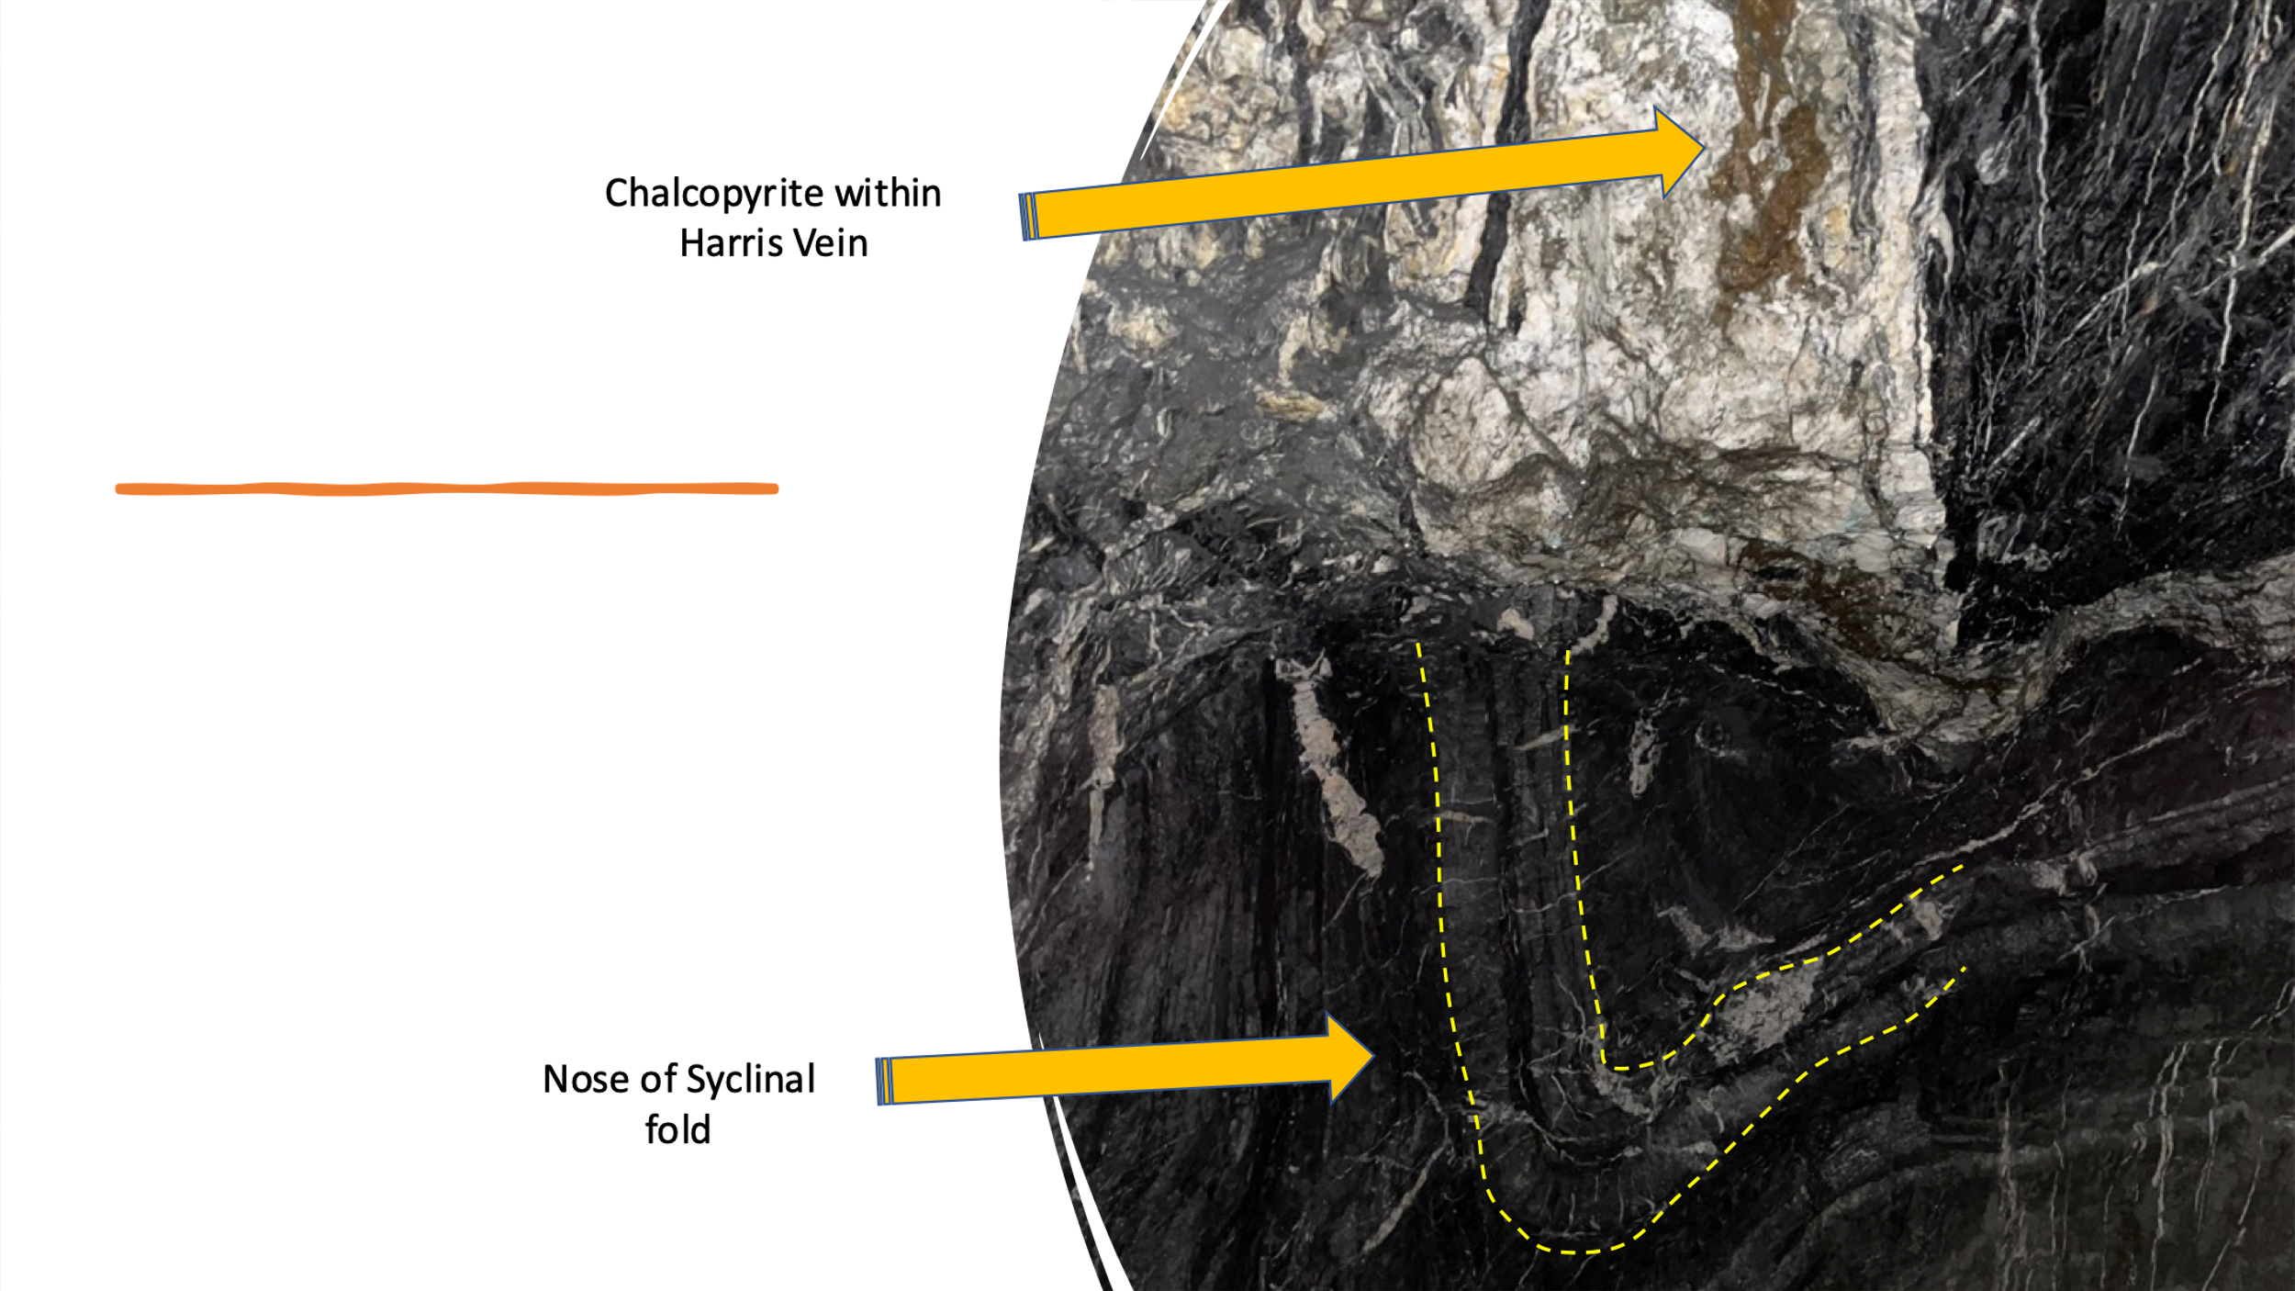
Table 1 – Harris Occurrence 2021 Surface Samples
Sample No. | Elevation (m) | Type of Sample | Width (m) | Copper (Cu) Grade %
D - 723209 | 1,782 | Rubble |  | 2.21
D - 723228 | 1,801 | Chip | 0.60 | 3.76
D - 723229 | 1,801 | Chip | 0.70 | 1.49
D - 723230 | 1,801 | Chip | 0.20 | 5.72
Mean Average | 1,801 | Chip | 1.70 | 2.96
- 1% Copper per tonne = 22.20 lbs.

In the area that the Harris vein terminates, by the folding, parallel tensions fractures renealed or
healed with bull white quartz and carbonate is seen. See Photos 4 and 5 below.

Photo 4 – Harris Vein Underground Veining – 1,782 meters vertical
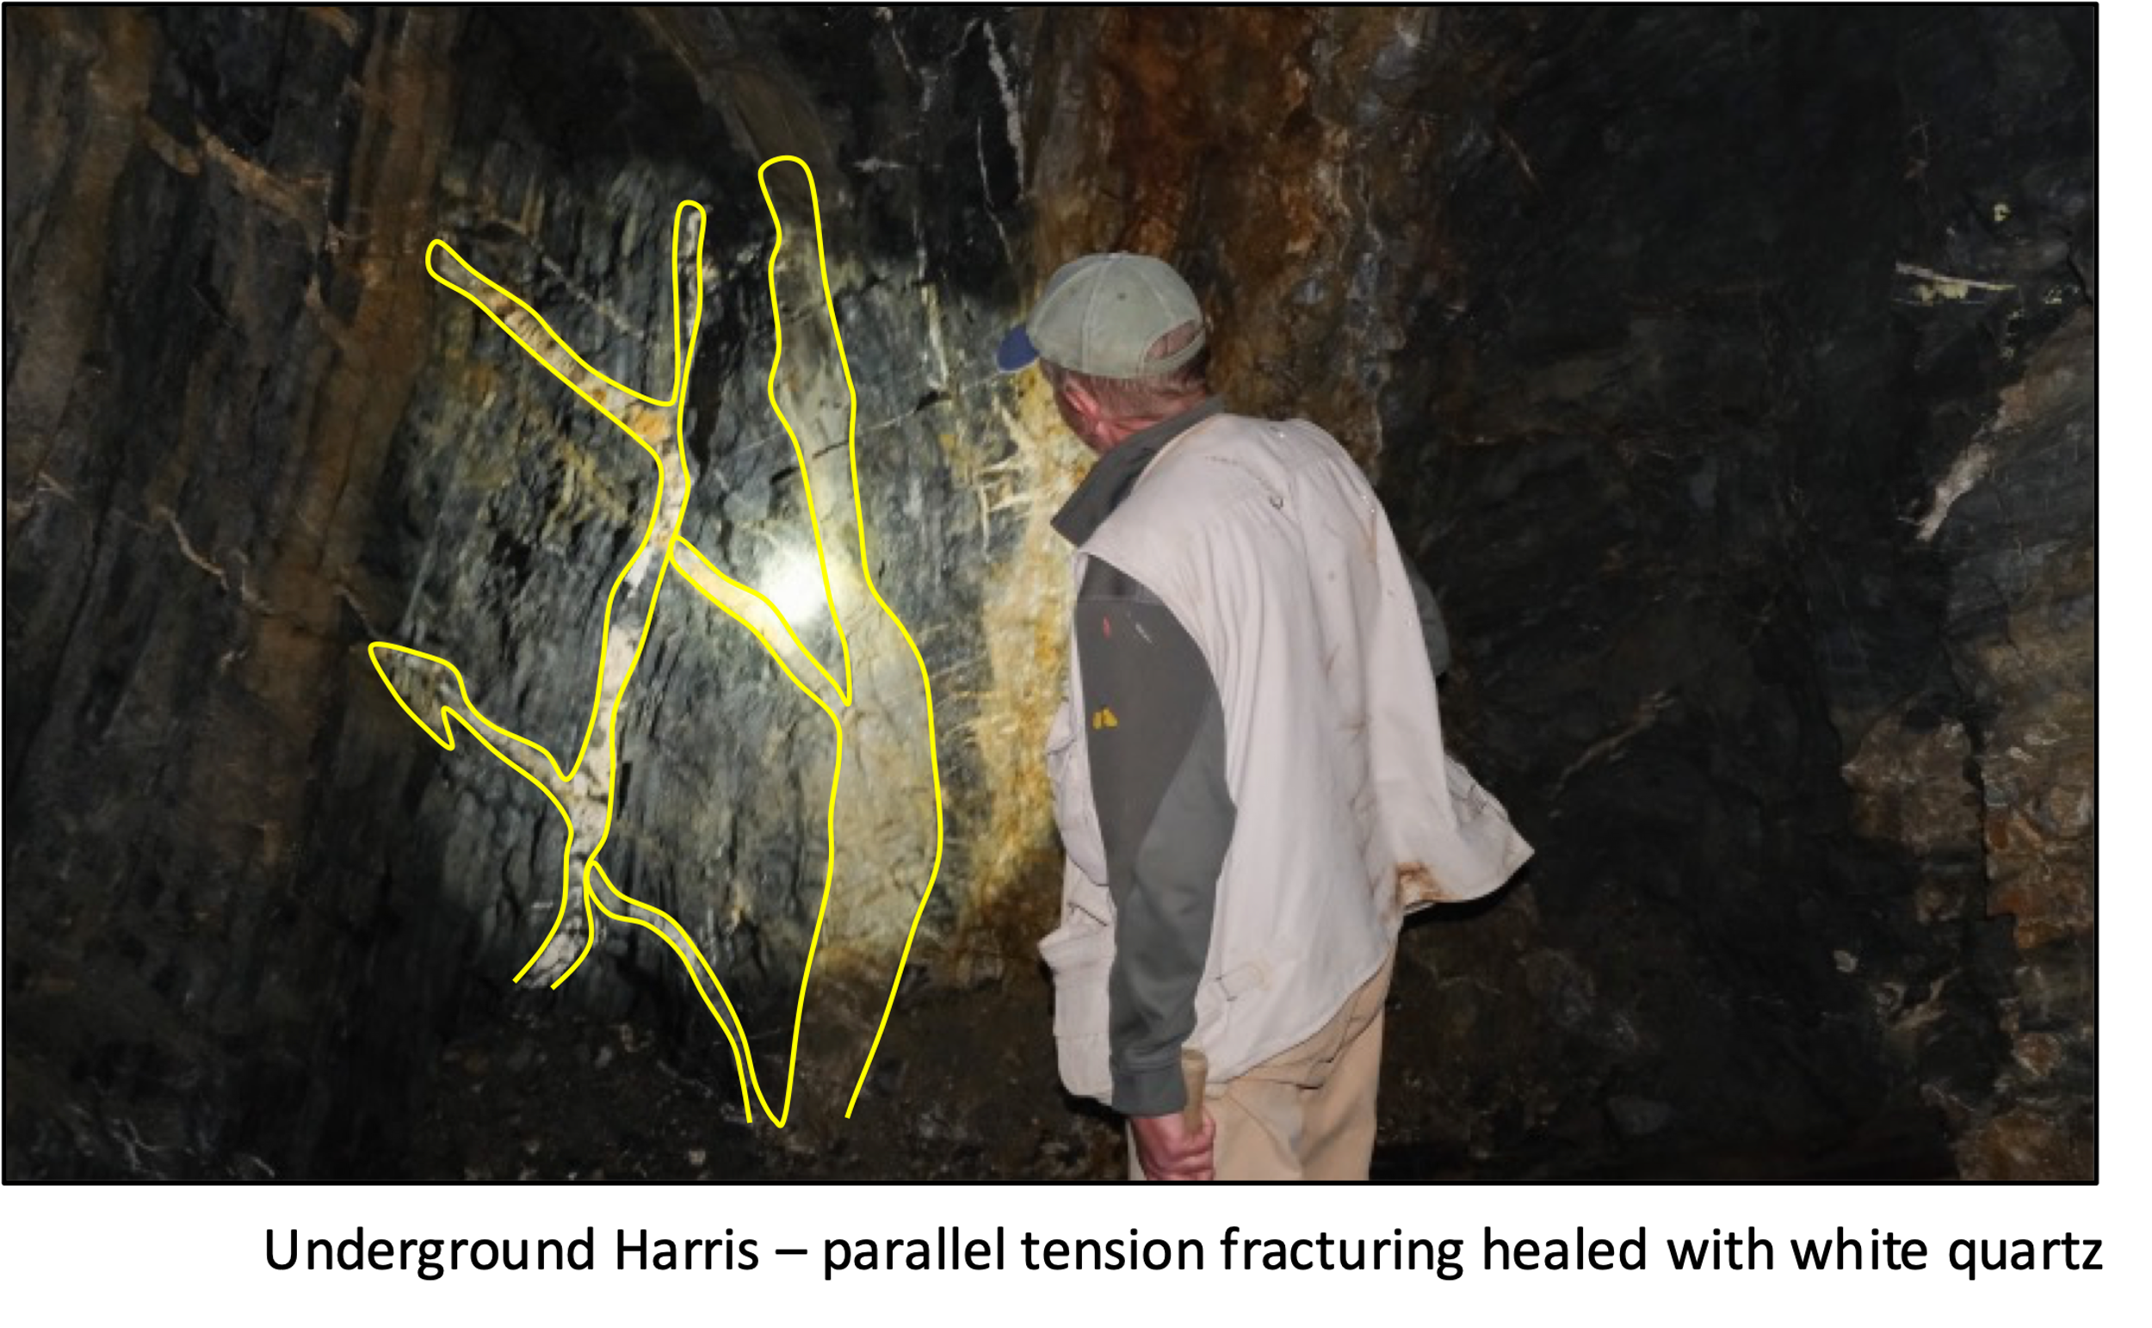
The photo below is a close up of the compressional tension veins formed due to the folding of the slate / share units. See Photo 5 below.
Photo 5 – Harris Vein Underground Veining – 1,782 meters vertical
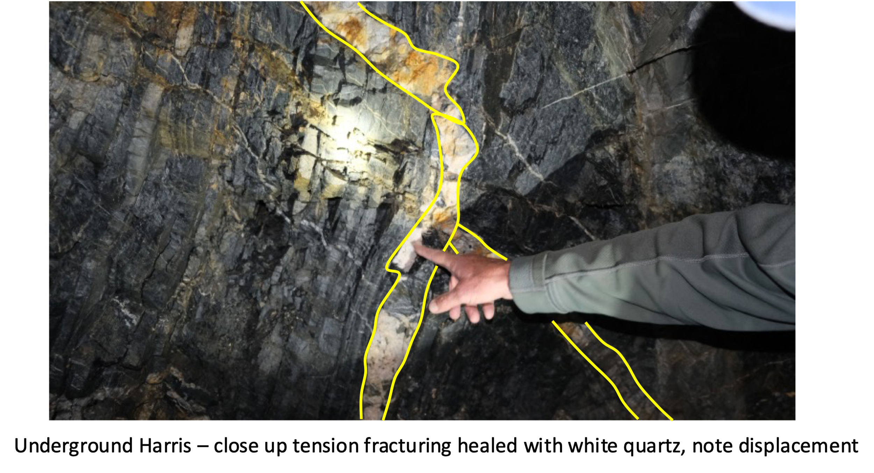
The surface expression of the Harris vein, 19 meters above the underground adit was sampled over a width of 1.70 meters.
Channel Sample # D – 723228 consisted of quartz carbonate veining with sheared siltstone and graphitic shales on the contact, occasional vugs were seen and moderate malachite copper alteration with a trace of azurite. It contained 1-2% disseminated chalcopyrite over all with patches of chalcopyrite. The channel sample was taken over a width of 0.60 meters and returned 3.76% copper. See Photo 6 below of hand sample of mineralized zone sampled.
Photo 6 – Harris Vein Surface Veining – 1,801 meters vertical
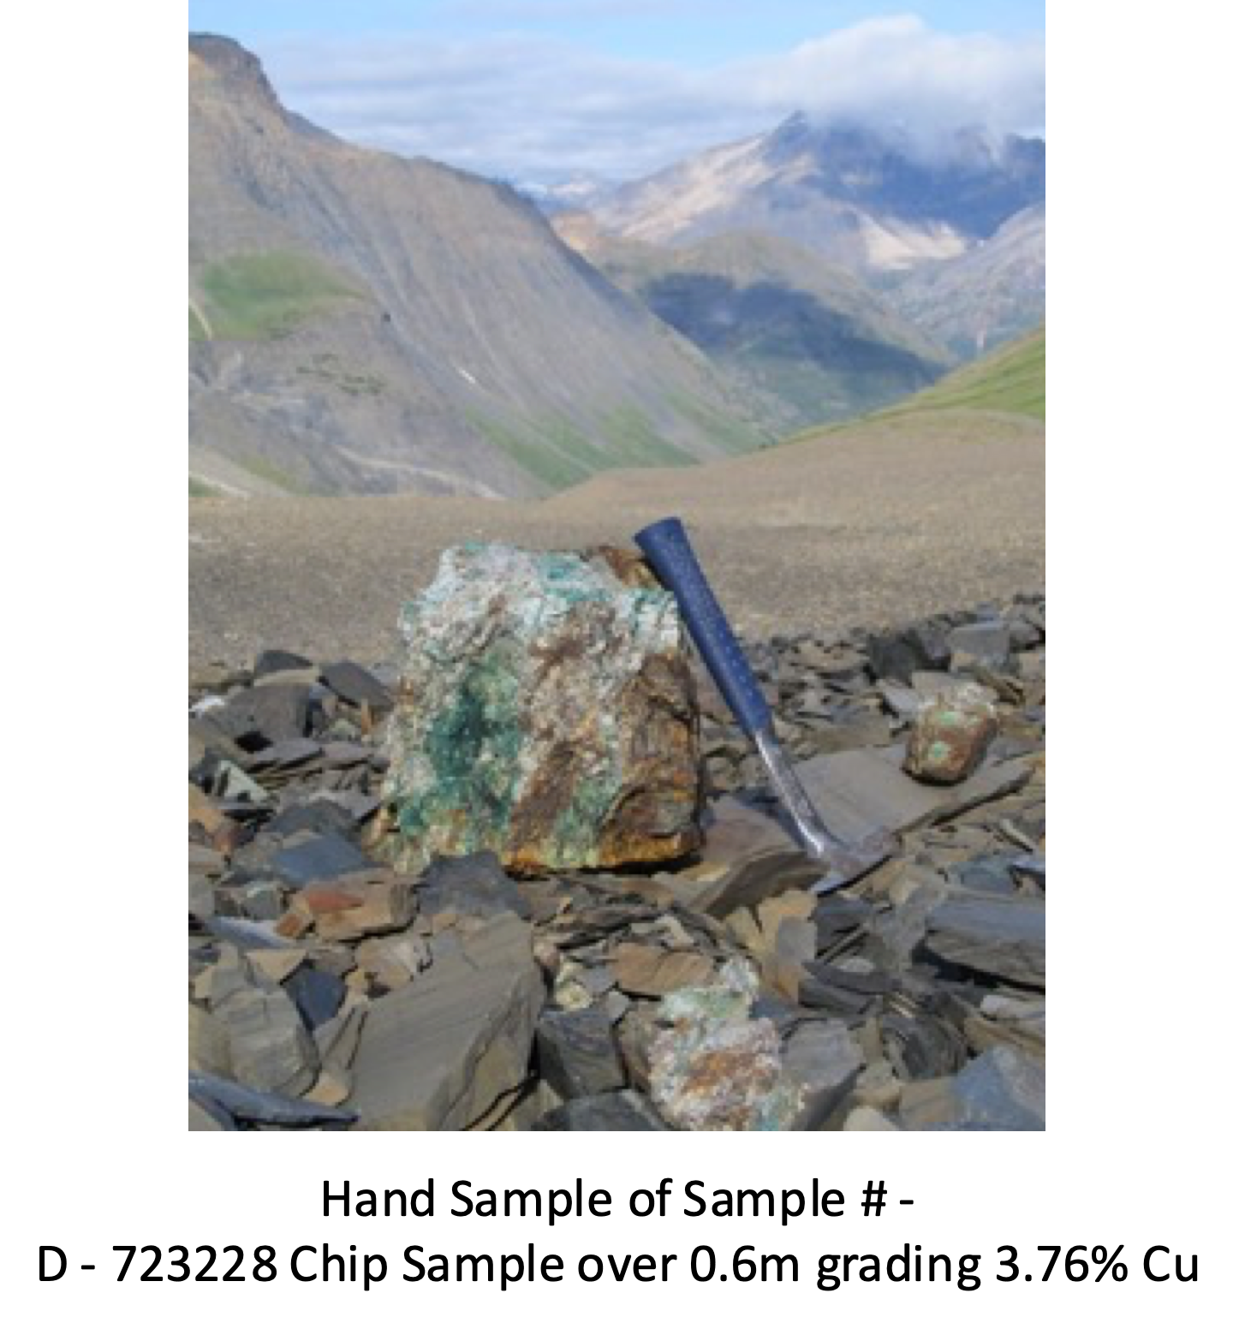
Next to the above-described sample, the next collected chip sample D – 723229 contained quartz with minor carbonate, such as is associated with micro fractures, minor malachite copper alteration with 1% chalcopyrite as disseminations, blebs, small blebs and fracture filling, with a trace of bornite. This chip sample was taken over 0.70 meters and assayed 1.49% copper.
Chip sample D – 723230 next to the above described sample completed the sampling of the width of the vein over the entire 1.70 meter width and was composed of quartz veining, was colored minor dark brown with rusty patches on the weathered surface with moderate malachite copper alteration and 2-3% chalcopyrite as patches. The 0.20 meters width samples returned 5.72% copper.
The weighted mean average of the 3 continuous chip samples over the 1.70 meters width averaged 2.95% copper

Moving Forwards
The Company will not be further evaluating the Harris vein and it appears to be terminated.
QA QC Procedure

Analytical results of sampling reported by Fabled Copper Corp represent rock samples submitted by Fabled Copper Corp staff directly to ALS Chemex, Vancouver, British Columbia Canada. Samples were crushed, split, and pulverized as per ALS Chemex method PREP-31, then analyzed for ME-ICP61 33 element package by four acid digestion with ICP-AES Finish. ME-GRA21 method for Au and Ag by fire assay and gravimetric finish, 30g nominal sample weight.
Over Limit Methods
For samples triggering precious metal over-limit thresholds of 10 g/t Au or 100 g/t Ag, the following is being used:
Au-GRA21 Au by fire assay and gravimetric finish with 30 g sample.
Ag-GRA21 Ag by fire assay and gravimetric finish.
Fabled Copper Corp. monitors QA/QC using commercially sourced standards and locally sourced blank materials inserted within the sample sequence at regular intervals.
Listing on Frankfurt Stock Exchange.
Fabled is also pleased to announce the listing of its common shares for trading on the Frankfurt Stock Exchange (“FSE”) under the symbol "XZ7" and WKN # “AC39NH “.

The FSE is the world's third largest organized exchange-trading market in terms of turnover and dealings in securities. With over 3,000 international companies listed on the FSE and investors directly connected to the FSE, the FSE represent 35% of the world's investment capital.

The Company's shares will now be cross-listed on the TSX Venture Exchange and the Frankfurt Stock Exchange. Fabled expects the FSE listing will help increase trading liquidity and facilitate investment in the Company by institutional and retail investors across Europe. This listing does not impact the total number of common shares outstanding in the Company.

Mr. Peter Hawley, President and CEO of Fabled, commented: "Fabled is committed to building shareholder value and the Frankfurt Stock Exchange listing will enable international investors to participate in the Company’s growth and development. We feel this is a great opportunity to introduce Fabled to a European investing audience.”

About Fabled Copper Corp.

Fabled Copper is a junior mining exploration company. Its current focus is to creating value for stakeholders through the exploration and development of its existing copper properties located in northern British Columbia. The Muskwa Project comprises a total of 76 claims in two non-contiguous blocks and totals approximately 8,064.9 hectares, located in the Liard Mining Division in northern British Columbia.

Mr. Peter J. Hawley, President and C.E.O.
Fabled Copper Corp.
Phone: (819) 316-0919
peter@fabledcopper.org

For further information please contact:

info@fabledcopper.org

The technical information contained in this news release has been approved by Peter J. Hawley, P.Geo. President and C.E.O. of Fabled, who is a Qualified Person as defined in National Instrument 43-101 - Standards of Disclosure for Mineral Projects.

The Canadian Securities Exchange does not accept responsibility for the adequacy or accuracy of this release.

Certain statements contained in this news release constitute "forward-looking information" as such term is used in applicable Canadian securities laws. Forward-looking information is based on plans, expectations and estimates of management at the date the information is provided and is subject to certain factors and assumptions, including, that the Company's financial condition and development plans do not change as a result of unforeseen events and that the Company obtains any required regulatory approvals.

Forward-looking information is subject to a variety of risks and uncertainties and other factors that could cause plans, estimates and actual results to vary materially from those projected in such forward-looking information. Some of the risks and other factors that could cause results to differ materially from those expressed in the forward-looking statements include, but are not limited to: impacts from the coronavirus or other epidemics, general economic conditions in Canada, the United States and globally; industry conditions, including fluctuations in commodity prices; governmental regulation of the mining industry, including environmental regulation; geological, technical and drilling problems; unanticipated operating events; competition for and/or inability to retain drilling rigs and other services; the availability of capital
on acceptable terms; the need to obtain required approvals from regulatory authorities; stock market volatility; volatility in market prices for commodities; liabilities inherent in mining operations; changes in tax laws and incentive programs relating to the mining industry; as well as the other risks and uncertainties applicable to the Company as set forth in the Company's continuous disclosure filings filed under the Company's profile at www.sedar.com. The Company undertakes no obligation to update these forward-looking statements, other than as required by applicable law.

